Mastering Embedded System Online Diploma

<https://www.learn-in-depth.com/>

Second Term (Final Project)

Eng. Mohamed Abd El-Naby Mohamed

My Profile:

<https://www.learn-in-depth.com/online-diploma/mahameda.naby@gmail.com>

Table of Contents

LIST OF FIGURES 4

Description 5

System Specifications 6

ECU1 6

ECU2 6

ECU3 6

System Assumptions: 6

Project Overview: 7

i- All System 7

ii- Calls 7

System Architecture 9

1- Case study 9

2- Method 9

3- Requirement 9

4- Space exploration/partitioning 10

5- System Analysis 11

i- Use Case Diagram 11

ii- Simple Activity Diagram 13

iii- Sequence Diagram (UML) 15

6- System Design 18

Boot Sequence of STM32 18

Map File 19

Memory dump 20

Some of Symbols 21

ELF image details 22

Hardware Simulation 23

Test Cases 23

- ECU1 23

- ECU2 25

- ECU1 27

# LIST OF FIGURES

Figure 1:Project Overview 7

Figure 2:ECU1 Calls 7

Figure 3:ECU2 Calls 8

Figure 4:ECU3 Calls 8

Figure 5:System Architecture 9

Figure 6:System Requirement 9

Figure 7:System Partitioning 10

Figure 8:ECU2 Use Case Diagram 11

Figure 9: ECU1 & ECU3 Use Case Diagram 12

Figure 10:ECU2 Activity Diagram 13

Figure 11:ECU1 Activity Diagram 13

Figure 12:ECU3 Activity Diagram 14

Figure 13:ECU1 UML Diagram 15

Figure 14:ECU2 UML Diagram 16

Figure 15:ECU3 UML Diagram 17

Figure 16:System Design 18

Figure 17:Sequence 19

Figure 18:Vector table position in map file 19

Figure 19:Memory Dump with debug section 20

Figure 20:Symbols of ELF image 21

Figure 21:ELF image details 22

Figure 22:simulation test 23

Figure 23:ECU1 TEST CASES 23

Figure 24:ECU1 TEST CASES 24

Figure 25:ECU1 TEST CASES 24

Figure 26:ECU1 TEST CASES 24

Figure 27:ECU2 TEST CASES 25

Figure 28:ECU2 TEST CASES 25

Figure 29:ECU2 TEST CASES 26

Figure 30:ECU2 TEST CASES 26

Figure 31:ECU3 TEST CASES 27

Figure 32:ECU3 TEST CASES 27

Figure 33:ECU3 TEST CASES 27

Figure 34:ECU3 TEST CASES 28

Private Parking Garage

# Description

This Project aims to make a design for a private parking garage area for people in a specific area or garage for a company. This system is split into three ECUs: **First ECU for the entrance gate**

This ECU is responsible for the gate that is based on the servo motor, the RFID reader based on UART for the user interface, Buzzer for the beep sound when the driver enters an unauthorized ID, and Some LEDs like green and red for authorized and unauthorized ID.

**Second ECU for admin dashboard**

This ECU is responsible for the admin privileges to add, delete, and edit driver data. The system may have more than one admin, each one of them has its username and password.

The ECU has an LCD and keypad as an admin interface, a UART device for entering admin data, and a seven-segment to display the number of available slots in the garage.

**Third ECU for the exit gate**

This ECU is responsible for the gate that is based on the servo motor, the RFID reader based on UART for the user interface, Buzzer for the beep sound when the driver enters an unauthorized ID, and Some LEDs like green and red for authorized and unauthorized ID.

LCD will display some messages for the driver to determine what will do.

The Whole system is connected together. when a driver enters a valid ID the ECU1 sends data through SPI to ECU2, and the ECU2 starts checking if the ID is valid or not and checking if it is inside the garage and wants to exit from the entrance gate then the ECU2 return the result of checking to ECU1 to display the result of computing on the LCD is valid ID or invalid ID.

When the driver wants to exit the garage space and enter the ID the ECU3 sends the driver data to ECU2, and the ECU2 starts checking if the ID is valid or not and checking if it is outside the garage and wants to enter from the exit gate then the ECU2 return the result of checking to ECU1 to display the result of computing on the LCD is valid ID or invalid ID.

# System Specifications

## ECU1

1. Control The servo motor of the entrance gate.
2. Display the states on LCD

## ECU2

1. Holds Predefined admins data.
2. Validate the driver data.
3. Display admin dashboard.
4. Display number of available slots in garage.

## ECU3

1. Control The servo motor of the exit gate.
2. Display the states on LCD

# System Assumptions:

1. The Distance between the ECU1 and ECU2 is shorter than 50 cm.
2. The Distance between the ECU3 and ECU2 is shorter than 50 cm.
3. Controller maintenance is not modeled.
4. Sensors never fail.
5. Communication wires are never damaged.

# Project Overview:

## All System

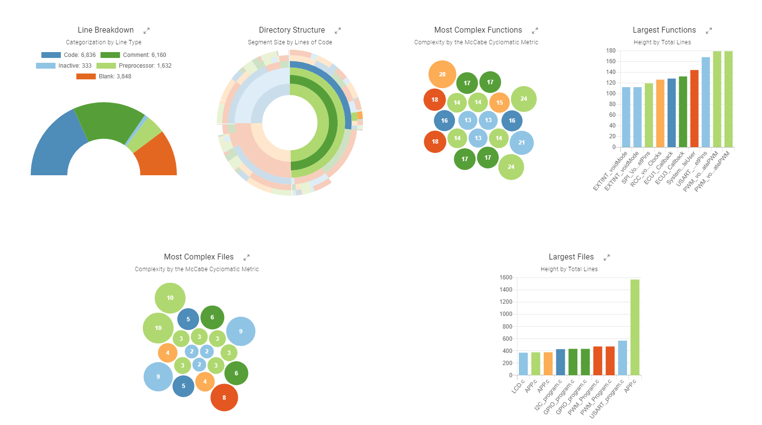

Figure 1:Project Overview

## Calls

* ECU1

Figure 2:ECU1 Calls

* ECU2

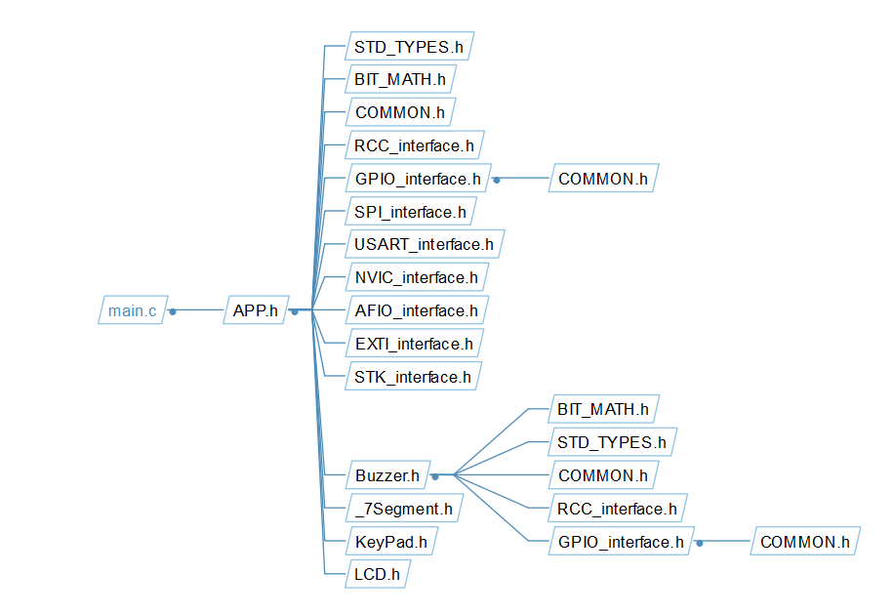

Figure 3:ECU2 Calls

* ECU3

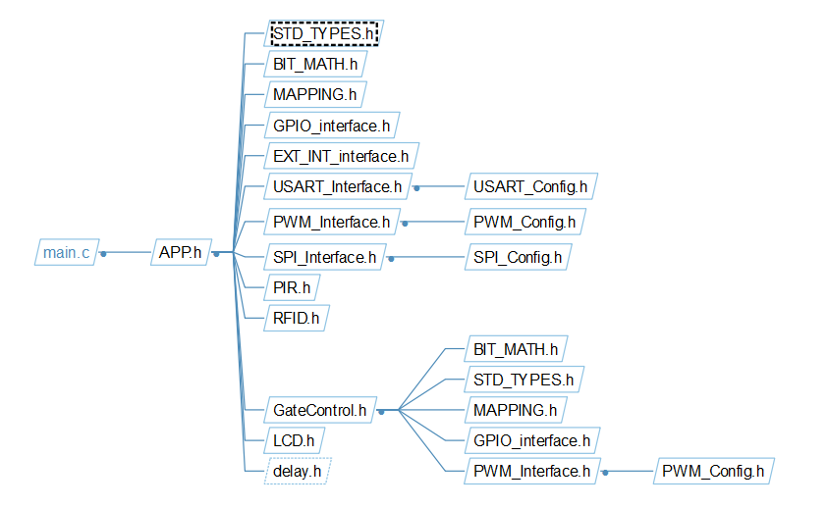

Figure 4:ECU3 Calls

# System Architecture

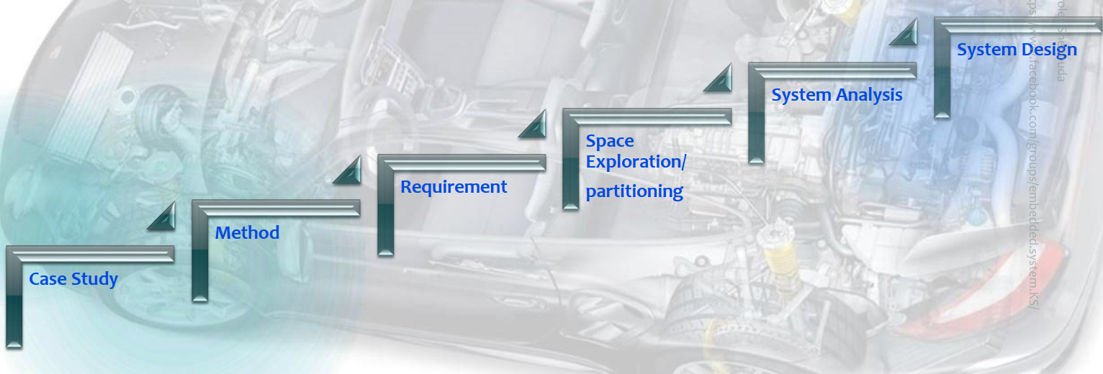

Figure 5:System Architecture

## Case study

software that controls the private parking garage.

## Method

Adaptive Technique: Agile Scrum Methodology

## Requirement

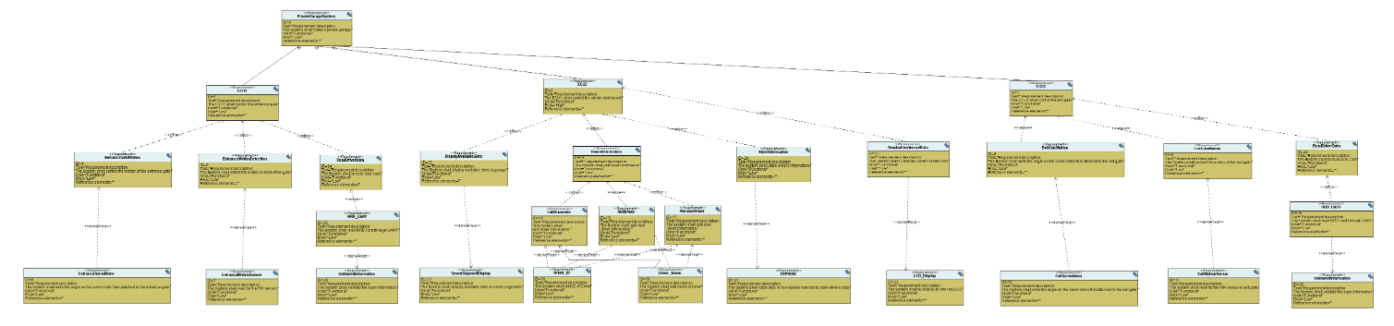

Figure 6:System Requirement

## Space exploration/partitioning

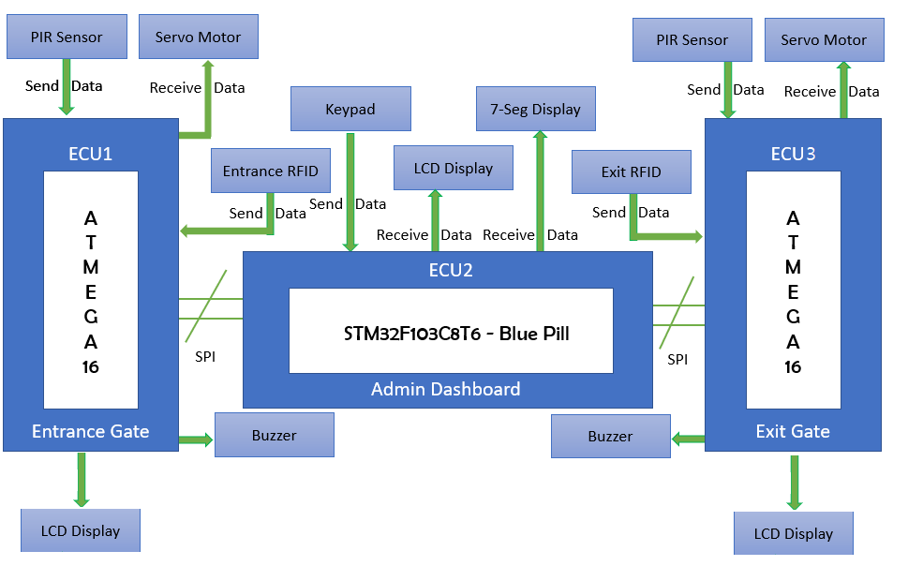

Figure 7:System Partitioning

I used STM32F103C8T6 - Blue Pill board for ECU2 which based on ARM Cortex m3 microprocessor its specification

1. ARM 32-bit Cortex™-M3 CPU Core
2. 72 MHz maximum frequency
3. Single-cycle multiplication and hardware division.
4. Memories
5. 32 Kbytes of Flash memory
6. 10 Kbytes of SRAM
7. Clock, reset and supply management
8. 2.0 to 3.6 V application supply and I/Os.
9. 4-to-16 MHz crystal oscillator.
10. 32 kHz oscillator for RTC with calibration

And used ATmega16 For ECU1 and ECU3

## System Analysis

### Use Case Diagram

Figure 8:ECU2 Use Case Diagram

Figure 9: ECU1 & ECU3 Use Case Diagram

### Simple Activity Diagram

Figure 10:ECU2 Activity Diagram

Figure 11:ECU1 Activity Diagram

Figure 12:ECU3 Activity Diagram

### Sequence Diagram (UML)

* ECU1 UML

Figure 13:ECU1 UML Diagram

* ECU2 UML

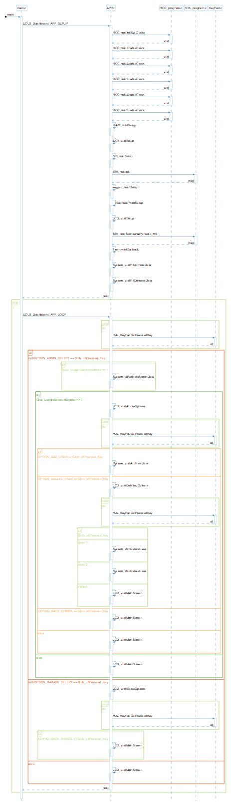

Figure 14:ECU2 UML Diagram

* ECU3 UML

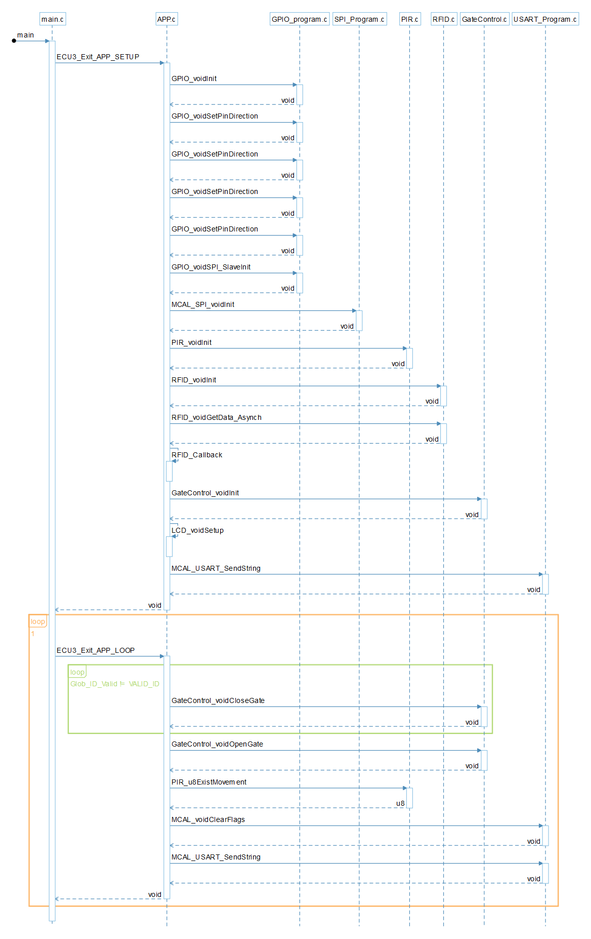

Figure 15:ECU3 UML Diagram

## System Design

Figure 16:System Design

# Boot Sequence of STM32

Entry Point (Reset Section)

Reset section

FLASH MEM

BareMetal SW

Figure 17:Sequence

Our entry point is reset handler that move .data from FLASH to SRAM and reserve .bss section in SRAM.

# Map File

* Memory map



Start address of flash memory



Figure 18:Vector table position in map file

# Memory dump

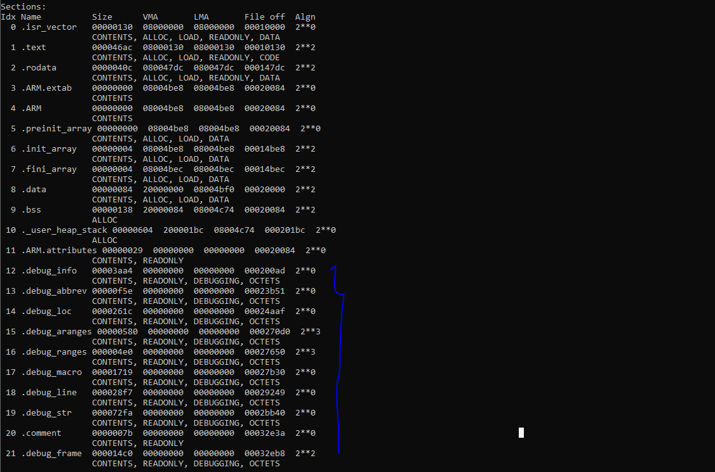

Debug info

Figure 19:Memory Dump with debug section

# Some of Symbols

Figure 20:Symbols of ELF image

All symbols successfully resolved

For each symbol check [link](https://sourceware.org/binutils/docs/binutils/nm.html)

# ELF image details

Figure 21:ELF image details

# Hardware Simulation

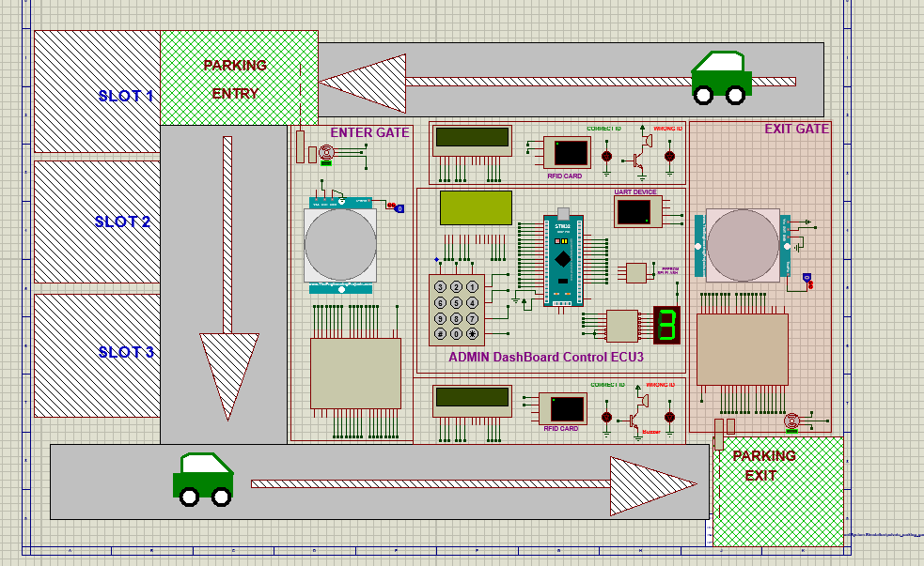

Figure 22:simulation test

# Test Cases

### ECU1

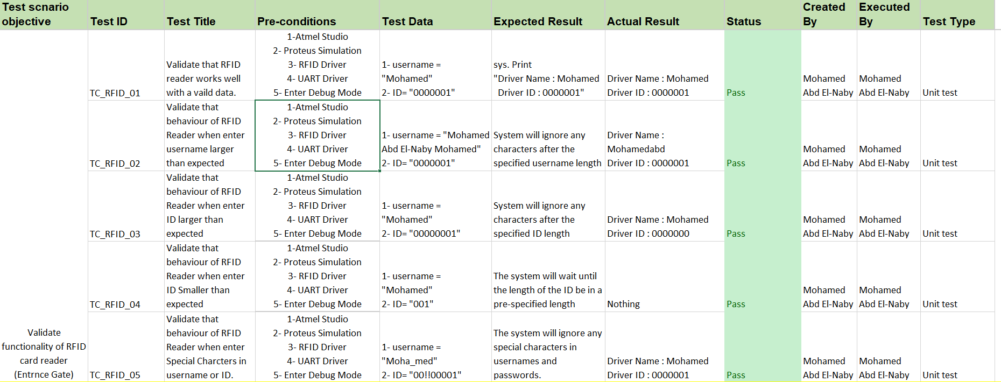

Figure 23:ECU1 TEST CASES

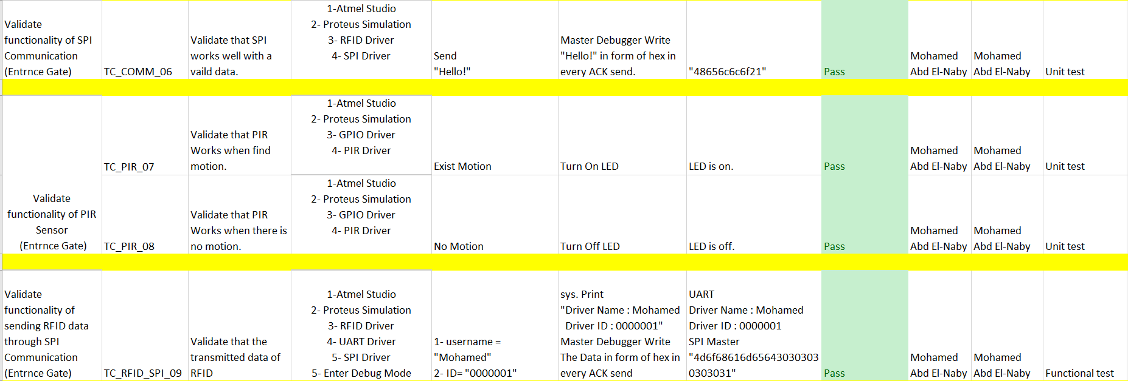

Figure 24:ECU1 TEST CASES

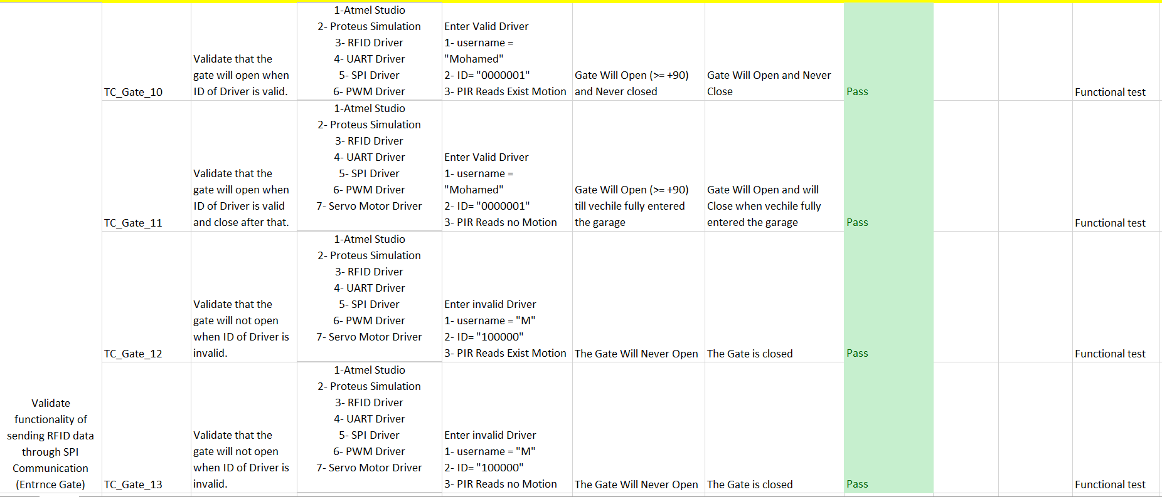

Figure 25:ECU1 TEST CASES

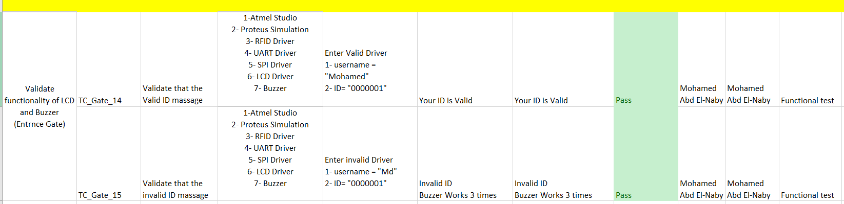

Figure 26:ECU1 TEST CASES

### ECU2

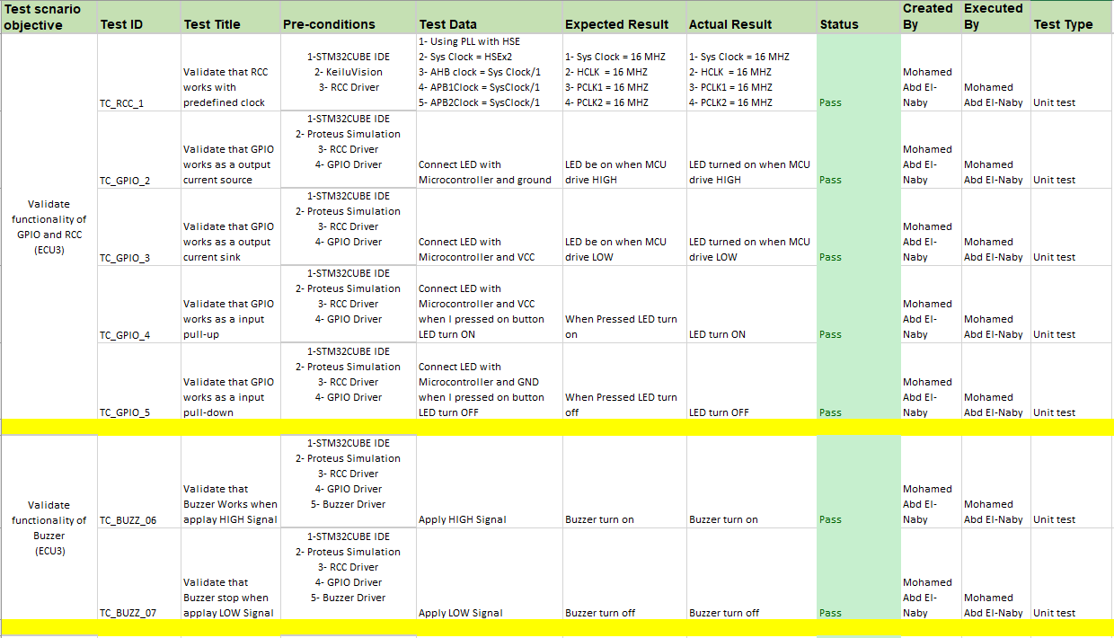

Figure 27:ECU2 TEST CASES

Figure 28:ECU2 TEST CASES

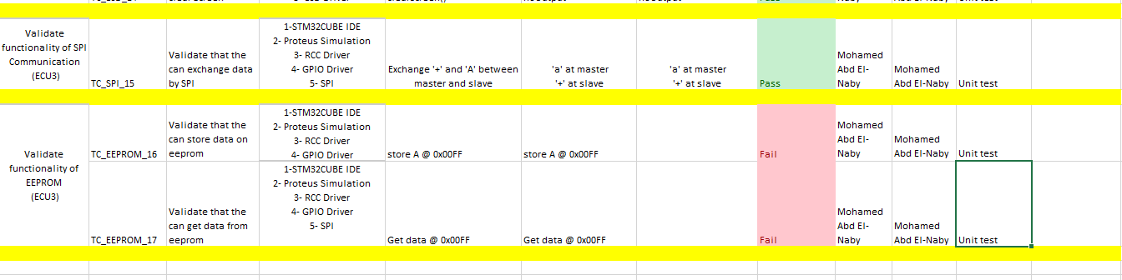

Figure 29:ECU2 TEST CASES

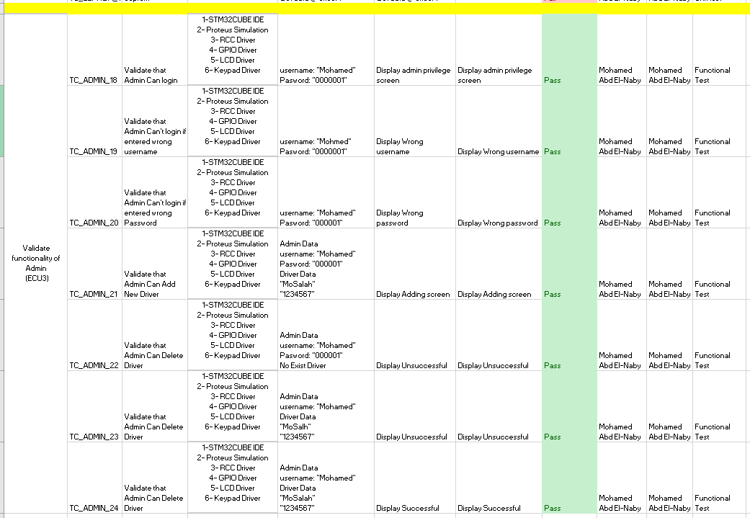

Figure 30:ECU2 TEST CASES

### ECU1



Figure 31:ECU3 TEST CASES



Figure 32:ECU3 TEST CASES



Figure 33:ECU3 TEST CASES



Figure 34:ECU3 TEST CASES